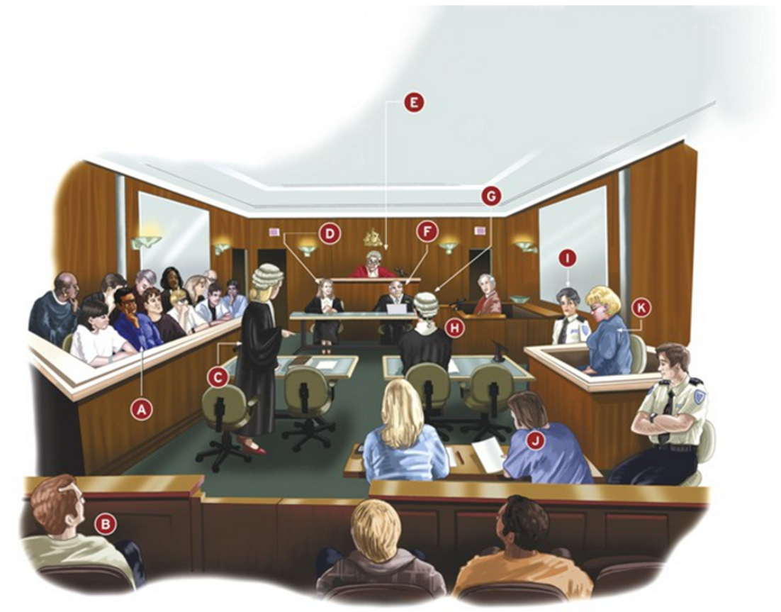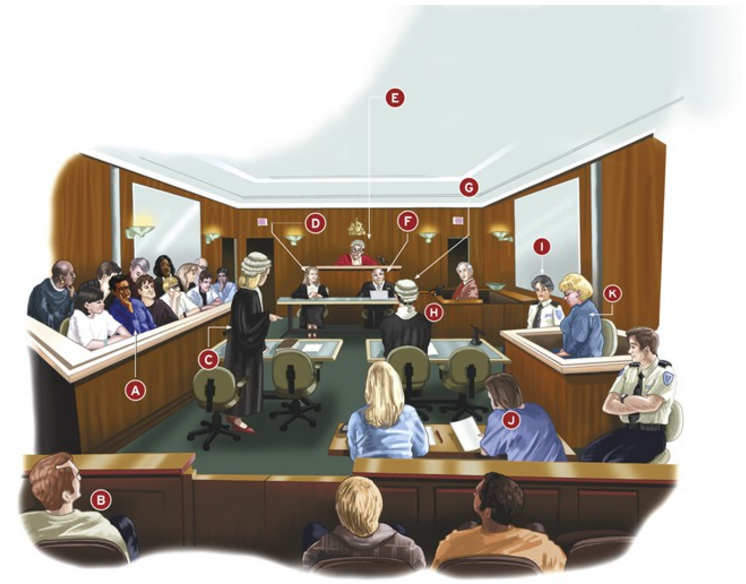

|  |  |
| --- | --- |
| **A** | Anyone whose name is on the electoral roll can be called as a juror, although some people are ineligible, excused or disqualified. In a criminal case, the jury consists of 12 people. In a civil matter, only 6 people decide how much money should be paid for damages. In a criminal trial, the jury must decide beyond reasonable doubt whether a person is guilty. All the jurors have to agree. |
| **B** | Members of the public, who listen to and observe the court proceedings. |
| **C** | In criminal cases, the prosecutor has to convince the jury that a person is guilty. This is done by asking questions of witnesses to draw out relevant information. In civil cases, a barrister will act on behalf of the plaintiff. Their role is to present reasons that their client should receive compensation. |
| **D** | The judge’s associate is a trained lawyer who manages much of the paperwork. |
| **E** | The judge is addressed ad ‘Your Honour’. He or she listens to arguments presented by the prosecutor and the counsel for the defence, and is not allowed to ask a witness questions (except to clarify a point). When there is a jury, the judge has to make sure jury members understand the proceedings and evidence presented. If a jury announces a guilty verdict (decision), the judge decides the sentence or punishment. |
| **F** | The tipstaff helps the judge keep order in the court. |
| **G** | In criminal cases, the counsel for the defence represents the accused. If the accused pleads guilty, the counsel for the defence presents argument to try to lessen the punishment. If the client pleads not guilty, defence counsel must convince the judge or jury that the client is innocent. In a civil case, the counsel for the defence attempts to convince a judge (and occasionally a jury) that no wrong has been committed. If successful, the client does not have to pay damages. |
| **H** | Witness box, from which people give evidence. |
| **I** | A prison officer from the prison where the accused person has been held. |
| **J** | Members of the media, who observe proceedings so they can report what happens. |
| **K** | The accused. |

|  |
| --- |
| Anyone whose name is on the electoral roll can be called as a juror, although some people are ineligible, excused or disqualified. In a criminal case, the jury consists of 12 people. In a civil matter, only 6 people decide how much money should be paid for damages. In a criminal trial, the jury must decide beyond reasonable doubt whether a person is guilty. All the jurors have to agree. |
| Members of the public, who listen to and observe the court proceedings. |
| In criminal cases, the prosecutor has to convince the jury that a person is guilty. This is done by asking questions of witnesses to draw out relevant information. In civil cases, a barrister will act on behalf of the plaintiff. Their role is to present reasons that their client should receive compensation. |
| The judge’s associate is a trained lawyer who manages much of the paperwork. |
| The judge is addressed ad ‘Your Honour’. He or she listens to arguments presented by the prosecutor and the counsel for the defence, and is not allowed to ask a witness questions (except to clarify a point). When there is a jury, the judge has to make sure jury members understand the proceedings and evidence presented. If a jury announces a guilty verdict (decision), the judge decides the sentence or punishment. |
| The tipstaff helps the judge keep order in the court. |
| In criminal cases, the counsel for the defence represents the accused. If the accused pleads guilty, the counsel for the defence presents argument to try to lessen the punishment. If the client pleads not guilty, defence counsel must convince the judge or jury that the client is innocent. In a civil case, the counsel for the defence attempts to convince a judge (and occasionally a jury) that no wrong has been committed. If successful, the client does not have to pay damages. |
| Witness box, from which people give evidence. |
| A prison officer from the prison where the accused person has been held. |
| Members of the media, who observe proceedings so they can report what happens. |
| The accused. |

|  |  |
| --- | --- |
| **A** |  |
| **B** |  |
| **C** |  |
| **D** |  |
| **E** |  |
| **F** |  |
| **G** |  |
| **H** |  |
| **I** |  |
| **J** |  |
| **K** |  |